Unit 9: Object-Oriented Software Architecture Lecturecast

Introduction to Software Architecture
Software architecture organises system components (structural) and aligns design with goals (functional). Below are the few definitions of software architecture:
Software architecture provides the blueprint for system design, while OOP principles ensure modularity, reusability, and security. Together, they enable scalable, maintainable, and robust systems.
Software architecture defines the high-level structure of a system, including its components, interactions, and design principles.
It ensures scalability, maintainability, and performance by organising code into logical structures.
Some common styles are: Layered, Microservices, Monolithic, Event - Driven

Summary
Software architecture refers to the high-level structure of a system, defining its components, their interactions, and the principles guiding its design. It serves as a blueprint for system organisation, ensuring scalability, maintainability, and performance. Example: Layered Architecture: A web application divided into:
Presentation Layer (UI) -> React.js
Business Logic Layer (Services) -> Spring Boot
Data Access Layer (Database) -> PostgreSQL
Software architecture is the strategic design of a system to meet technical and operational requirements (e.g., security, fault tolerance) while optimising trade-offs (e.g., cost vs. performance). Example: Microservices Architecture: An e-commerce platform with decoupled services:
User Service (Authentication) -> Node. Js
Order Service (Transaction) -> Java/Kafka
Product Service Inventory) -> Python/Django
• Django is a Python framework used for building secure, scalable web applications quickly.
- Node.js is a JavaScript runtime used for fast, real-time, event-driven applications like APIs, chats, and streaming services.
- Kafka is a distributed streaming platform used for handling real-time data pipelines, messaging, and event-driven systems(order service(transaction)).

• Technology:

Presentation Layer (UI) → React.js
- Role: Provides the user interface (UI) and handles user interactions.
- Technology: React.js is a JavaScript library developed by Facebook for building dynamic, component-based UIs.
- Key Features:
  - Component-based architecture: UI is broken into reusable pieces (buttons, forms, dashboards).
  - Virtual DOM: Efficiently updates only parts of the page that change, improving performance.
  - Declarative syntax: Developers describe what the UI should look like, React handles the rendering.
- Analogy: Think of React as the “shop front” of a store — it’s what customers see and interact with.
What is the DOM?
- The Document Object Model (DOM) is a tree-like structure that represents everything on a web page (HTML elements, attributes, text).
- Browsers use the DOM to render and update what you see on screen.
- Example: If you change a button’s text, the DOM updates that node and the browser redraws it.
Declarative Syntax Explained
- Definition: A way of writing code that expresses the desired outcome without explicitly listing the control flow or instructions.
- Focus: What should happen instead of how it happens.
- Contrast: Opposite of imperative syntax, where you give detailed instructions step by step.
Example in React.js
React uses declarative syntax for building UIs:
// Declarative
<h1>Hello, Jack!</h1>
This says: “Render a heading with this text.”
React figures out the steps needed to update the DOM.
Compare with imperative JavaScript:
// Imperative
const h1 = document.createElement("h1");
h1.textContent = "Hello, Jack!";
document.body.appendChild(h1);
• Imperative: You tell the chef step by step how to cook the dish.
- Declarative: You simply order “a pizza,” and the chef handles the process.

Here you manually tell the browser how to create and insert the element.

Business Logic Layer (Services) → Spring Boot
- Role: Implements the application’s core logic — rules, workflows, and processing.
- Technology: Spring Boot is a Java-based framework that simplifies building backend services.
- Key Features:
  - Dependency injection: Makes code modular and testable.
  - REST APIs: Easily expose endpoints for the UI to call (e.g., /login, /products).
  - Auto-configuration: Reduces boilerplate setup, speeding up development.
  - Security integration: Supports authentication, authorization, and secure communication.
- Analogy: Spring Boot is the “store manager” — it enforces rules, processes orders, and coordinates between the front desk (UI) and the warehouse (database).

Data Access Layer (Database) -> PostgreSQL
• Definition:
The Data Access Layer is a software layer that acts as an intermediary between your application’s business logic and the database.
Think of it as a translator: your app says “I need all users older than 25,” and the DAL converts that into the correct SQL query, sends it to the database, and returns the results in a usable format.
• Purpose:
  - Encapsulation: Keeps database logic separate from business logic.
  - Maintainability: If you change the database system later, you only update the DAL, not the whole app.
  - Security: Prevents direct database access, reducing risks like SQL injection.
  - Reusability: Common queries and operations can be centralized.
- Techniques Used:
- ORMs (Object-Relational Mappers) like SQLAlchemy, Django ORM, or Hibernate.
- Direct SQL Wrappers where DAL functions execute raw SQL queries.
- Stored Procedures accessed through DAL methods.
PostgreSQL
- Definition:
PostgreSQL is an open-source relational database management system (RDBMS) known for reliability, extensibility, and standards compliance.
- Key Features:
  - ACID compliance (ensures reliable transactions).
  - Advanced data types (JSON, arrays, hstore).
  - Strong concurrency control (MVCC — Multi-Version Concurrency Control).
  - Extensibility (you can add custom functions, data types, and operators).
  - Powerful indexing (B-tree, Hash, GiST, GIN, BRIN).
  - Cross-platform and widely supported.

Introduction to Object-Oriented Software Architecture
The OO software architecture can be defined from different perspectives. Some of the definitions of OO software architecture are presented below:
An OO software architecture organises a system into interacting objects (classes/instances) that encapsulate data and behaviour, promoting modularity and reusability.
Example: A banking system with Account, Transaction, and Customer classes, each handling specific responsibilities. An architecture leveraging OOP design patterns (e.g., Factory, Observer) to solve recurring structural problems in scalable systems.
Example: Using the Observer pattern in a stock market app to notify users (observers) when stock prices (subject) change. A hierarchical structure where each layer (e.g., UI, Business Logic, Data) is built using OOP principles for separation of concerns.
Example: A web app with: Presentation Layer: User Interface class (React/Vue), Business Layer: Order Service class (Java/Python), Data Layer: Database Repository class (SQL/NoSQL). A system decomposed into reusable OO components (e.g., libraries, services) communicating via well-defined interfaces.
Example: An e-commerce platform with: Payment Component (Stripe API wrapper), Inventory Component (Product catalogue manager). An architecture using inheritance and interfaces to enable interchangeable components without modifying core logic. Example: A payment processing system where Credit Card Payment and PayPal Payment implement a common payment interface. An architecture applying OOP principles (e.g., encapsulation) to enforce security (e.g., access control, input validation). Example: A User class with private password fields and public authentication() methods to prevent direct data exposure.

Importance of Software Architecture in System Design
Software architecture is the backbone of system design, ensuring scalability, maintainability, security, cost efficiency, performance and future adaptability. Here’s a list of key reasons why software architecture is critical in system design:
Defines system structure & organisation: Provides a blueprint for orgainsing components, modules, and interactions.
Example: Layered architecture separates UI, business logic, and data access for clarity. Ensures scalability: Supports horizontal/vertical scaling to handle growing user loads. Example: Microservices allow independent scaling of services (e.g., Auth Service vs. Payment Service).
Improves maintainability: Modular design makes it easier to update, debug, and enhance the system. Example: Using OOP principles (encapsulation) to isolate changes.
Enhance performance: Optimises resource usage (CPU, memory, network) through efficient design. Example: Caching layers in architecture reduce database load.
Enables reusability: Promotes reusable components (e.g., libraries, APIs) across projects. Example: A shared Authentication Module used in multiple apps.
Facilitates team collaboration: Clear architecture acts as a shared reference for developers, reducing conflicts. Example: UML (Unified Modeling Language: • Not a programming language: UML doesn’t execute; it’s purely for modeling and communication.) diagrams standardise communication in Agile teams.
Supports security: Builds security into the design (e.g., encryption, access control layers). Example: API gateways validate requests before reaching core services. Reduces development costs: Prevents costly redesigns by addressing requirements early. Example: Choosing serverless architecture to minimise infrastructure costs. Ensures reliability & fault tolerance: Designs for failures (e.g., retry mechanisms, redundancy). Example: Circuit breakers in microservices prevent cascading failures. Simplifies integration: Standardises how systems interact (APIs, message queues). Example: RESTful APIs enable seamless integration with third-party services.

Types of Software Architecture
• Monolithic = simple, tightly coupled, good for small apps.
- Microservices = complex, loosely coupled, scalable, good for large distributed systems.

Monolithic Architecture
A single-tiered, tightly coupled application where all components (UI, logic, database) are bundled together.
Characteristics:
  - Single codebase (e.g., a Java Spring Boot app with embedded frontend)
  - Shared memory space (all modules run in one process)
  - Simpler deployment (one executable/JAR file)
Example: A small e-commerce website where the frontend, backend, and database are in on application.
When to Use?
  - Simple applications (MVP, internal tools)
  - Small teams with limited DevOps overhead
  - Low scalability needs.
🧩 Minimum Viable Product (MVP)
- Definition:
An MVP is the simplest version of an application that includes just enough features to be usable by early customers and to validate the core idea.
It’s a way to test assumptions quickly without investing in a full-scale product.

Layered (N-Tier) Architecture
Divides the system into logical layers (e.g., Presentation, Business, Data).
Characteristics:
  - Separation of concerns (UI, logic, storage in separate layers)
  - Strict hierarch (request flow top-down)
  - Easier maintenance (isolated changes per layer)
Example: A banking app with: Presentation Layer (React.js frontend), Business Layer (Spring Boot backend), Data Layer (PostgreSQL database)
When to Use?
  - Enterprise applications (ERP, CRM systems)
  - Teams needing modularity but not extreme scalability

Microservices Architecture
Decouples the system into independent, loosely coupled services (each with its one database).
Characteristics:
  - Decentralised (each service can be developed, deployed, and scaled independently)
  - Polyglot persistence (different databases per service)
  - Complex orchestration (needs Kubernetes, Docker)
Example: Uber’s architecture includes Ride Service (handles booking), Driver Services (manages drivers), and Payment Service (processes transactions).
When to Use?
  - Large-scale, distributed systems (e-commerce, SaaS).
  - Teams needing independent deployments
  - High scalability and fault tolerance requirements

Serverless Architecture
Uses cloud functions (e.g., AWS Lambda, Azure Functions) that run on demand.
Characteristics:
  - No server management (cloud provider handles scalling)
  - Pay-per-use pricing
  - Stateless & ephemeral (short – lived executions)
Example: A file – processing ap where: Upload triggers a Lambda functions to resize images.
When to Use?
  - Sporadic workloads (batch jobs, cron tasks).
  - Cost-efficient scaling (no idle servers)

Event-Driven Architecture (EDA)
Components communicate via events (asynchronous messages).
Characteristics:
  - Loose coupling (services react to events, not direct calls)
  - Real-time Processing (e.g., Kafka, RabbitMQ)
  - Scalable & Resilient (handles spikes in traffic)
Example: A stock trading app where: Order Service publishes and “OrderPlaced” event, and Notification Service listens and sends alerts.
When to Use?
  - Real – time systems (IoT, chat apps, trading platforms)
  - High – throughput data processing (logs, analytics)
✅ Advantages
- Flexibility: Services can be added/removed without affecting others.
- Scalability: Handles high-throughput workloads.
- Resilience: Failures are isolated; events can be retried.
- Real-Time Insights: Perfect for systems needing instant reactions.
⚠️ Drawbacks
- Complexity: Requires careful design of event flows.
- Debugging Difficulty: Tracing event-driven interactions can be harder than direct calls.
- Event Storming: Too many events can overwhelm the system if not managed.
- Consistency: Eventual consistency instead of immediate consistency.

Service-Oriented Architecture
Uses reusable, interoperable services (often via APIs).
Characteristics:
  - Enterprise – focused (e.g., ESB for service orchestration)
  - Coarse – grained services (bigger than microservices)
  - Centralised governance (shared DB, common protocols)
Example: A legacy airline reservation system where: Booking Service (SOAP API), Payment Service (REST API).
When to Use?
  - Legacy modernisation (migrating monolithic apps)
  - Enterprise integration (multiple departments sharing services)
• SOA(Service-oriented Architecture) = enterprise-focused, coarse-grained services, centralized governance, often with SOAP/ESB.
- Microservices = cloud-native, fine-grained services, decentralized governance, often with REST/Kafka.

Comparison table
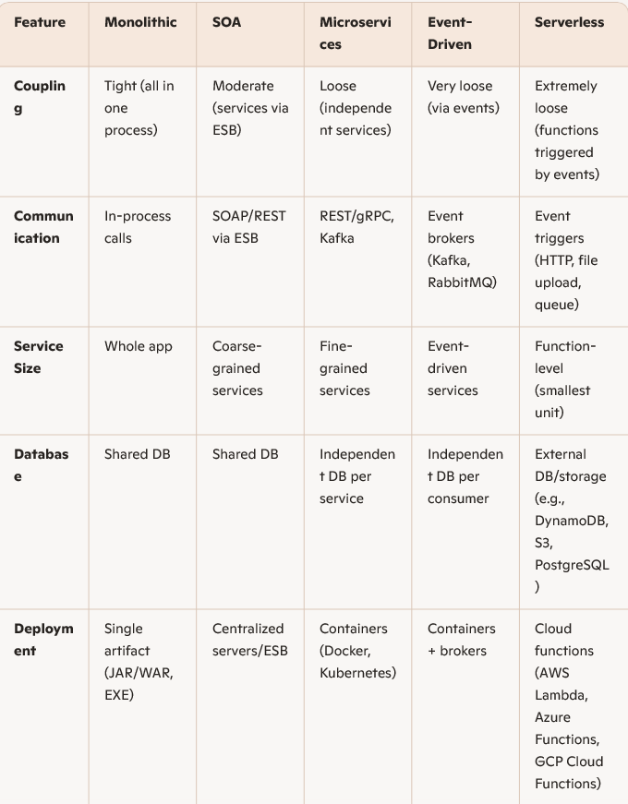
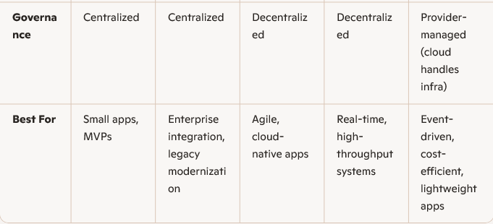

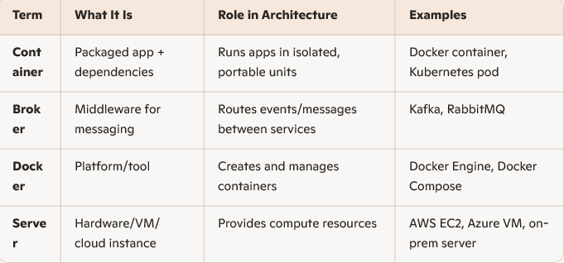

Comparison of Software Architecture Styles in System Design

Style | Coupling | Scalability | Complexity | Best For
Monolithic | Tight | Low | Low | Small apps, MVPs (• stripped-down version of an application to test the core idea)  )
Layered | Moderate | Medium | Medium | Enterprise apps (Enterprise Resource Planning,  Customer Relationship Management)
Microservices | Loose | High | High | Large-scale systems (Uber, Netflix)
Event-Driven | Loose | Very high | High | Real-time systems (IoT, trading
SOA | Moderate | Medium | Medium | Legacy integration (banks)
Serverless | Loose | Elastic | Medium | Event-triggered tasks (AWS Lambda)

⚖️ ERP vs CRM
✅ In short:
- ERP = Enterprise Resource Planning → manages internal business processes.
- CRM = Customer Relationship Management → manages customer-facing relationships and sales.
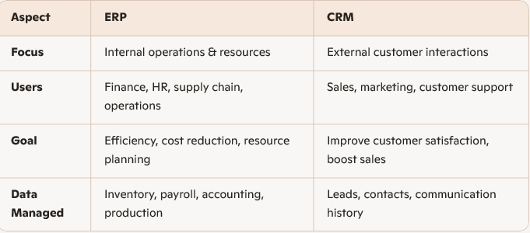

Key Takeaways
Monolithic: Simple but hard to scale.
Layered: Balanced for mid-sized apps.
Microservices: Best for large, scalable systems.
Event-Driven: Ideal for real-time processing.
SOA: Legacy enterprise integration.
Serverless: Cost-efficient for sporadic workloads.
Sporadic Workload
- Definition: A workload that is irregular, unpredictable, or infrequent.
Instead of running continuously, the application only needs compute resources at certain times — for example, when a user triggers an action or when an event occurs.
- Examples:
- A web app that only gets traffic during business hours.
- A reporting tool that runs once a day or once a week.
- A notification service that only sends alerts when specific events happen.
- An IoT system where sensors send data occasionally, not constantly.

Impacts of Software Architecture
Impacts of Software Architecture | Positive Impact | Negative Impact
Scalability | Microservices: Independent scaling of services improves performance under load.  Serverless: Auto – scales seamlessly. | Monolithic: Hard to scale vertically beyond server limits.  Microservices: Network latency between services.
Latency | Monolithic: Low latency (in – process calls).  Event – Driven: Async processing avoids bottlenecks. | Microservices: Network hops increase latency.  Serverless: Cold – start delays.
Fault Isolation | Microservices: Failure in one service does not crash the entire system.  Layered: Isolated layers limit blast radius. | Monolithic: Single point of failure.
Security | Microservices: Fine-grained access control per service.  Event – Driven: Decoupling reduces attack surface. | Microservices: More APIs = larger attack surface.  Monolithic: Breach compromises everything.

Trade-Offs Between Scalability, Maintainability and Performance

Scalability vs. Performance
This table compares the key differences between scalability and performance in system design, highlighting their respective focuses, architectural approaches, and trade-offs.
Factor | Scalability Focus | Performance Focus | Trade-off
Architecture | Microservices, Serverless | Monolithic, Layered | Scalability adds network overhead (latency)
Data Handling | Distributed databases (NoSQL, Sharding) | Single database (SQL, optimised queries) | Scaling databases may slow read-write ops.
Cost | Higher cloud/DevOps costs (e.g. Kubernetes) | Lower initial costs | Performance optimisations can limit scale
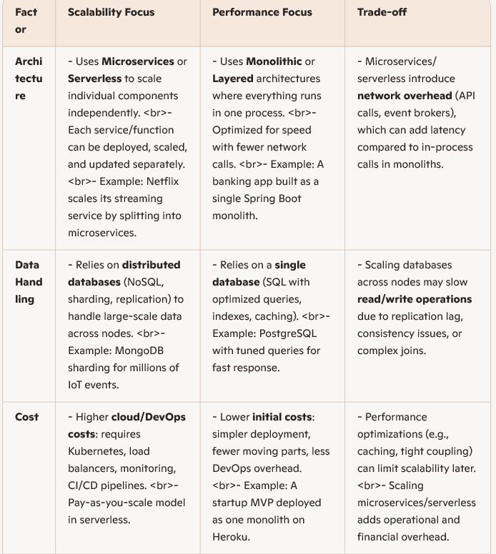
• Kafka → Real-time data streaming & messaging
• Kubernetes → Running, scaling, and managing applications
• Together → Power modern, scalable, event-driven systems

Key Takeaways
- Scalability = ability to handle more load by adding resources (horizontal scaling, distributed systems).
- Performance = ability to handle each request faster (low latency, optimized execution).
- Trade-off: Systems often sacrifice some performance to gain scalability, or vice versa.
⚡ Example Contrast
- A chat app MVP: built as a monolith with a single SQL database → fast performance, low cost.
- A global chat platform: rebuilt with microservices + Kafka + sharded NoSQL → scalable to millions of users, but each message may have slightly higher latency.

Scalability vs. Maintainability
This table contrasts scalability and maintainability in system design, highlighting differences in complexity, team requirements, and debugging challenges, along with their inherent trade-offs.
Factor | Maintainability Focus | Performance Focus | Trade-off
Complexity | Distributed systems (e.g. Kafka, Kubernetes) | Monolithic or modular codebases | Scaling adds operational complexity
Team skills | Requires DevOps/cloud expertise | Works with simpler workflows | Microservices need specialised knowledge
Debugging | Harder (distributed tracing needed) | Easier (single codebases) | Scalable systems are harder to debug

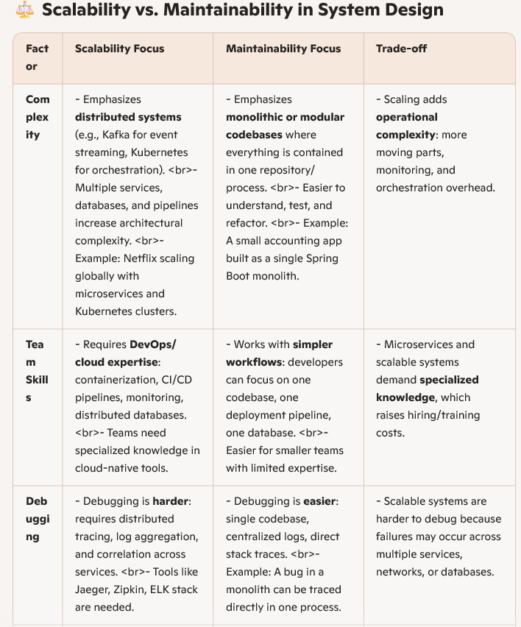
📌 Key Takeaways
- Scalability = ability to handle more load by distributing work across multiple services/nodes.
- Maintainability = ability to keep the system understandable, easy to debug, and simple to evolve.
- Trade-off: Highly scalable systems are harder to maintain because they introduce complexity, require specialized skills, and complicate debugging.
⚡ Example Contrast
- A startup MVP: built as a monolith → easy to debug, maintain, and evolve with a small team.
- A global e-commerce platform built with microservices + Kafka + Kubernetes → scales to millions of users, but debugging and maintaining the system requires advanced DevOps and distributed tracing tools.

Ways to Apply OOP Principles for System Scalability

Encapsulation for Modular Scaling:
What: Isolate components into self-contained classes with private data and public interfaces.
Why: Enables independent scaling of modules (e.g., scaling a PaymentService without affecting UserService).
Example:
public class PaymentService {
private PaymentProcessor processor; // Hidden implementation
public void processPayment() { ... } // Public API
}

Polymorphism for Flexible Extension:
What: Use interfaces/abstract classes to allow interchangeable components.
Why: Easily swap scalable implementations (e.g., switching from a local Cache to a distributed RedisCache).
Example:
class Cache(ABC):
@abstractmethod
def get(self, key): pass

class RedisCache(Cache): # Scalable implementation
def get(self, key): ...
Copy
from abc import ABC, abstractmethod

class Cache(ABC):
@abstractmethod
def get_data(self, key):
pass

class LocalCache(Cache):
def get_data(self, key):
# Local cache implementation
return f""Local cache: {key}""

class RedisCache(Cache):
def get_data(self, key):
# Redis cache implementation
return f""Redis cache: {key}""

# Polymorphic usage
def fetch_data(cache: Cache, key):
return cache.get_data(key)

local_cache = LocalCache()
redis_cache = RedisCache()

print(fetch_data(local_cache, ""example"")) # Output: Local cache: example
print(fetch_data(redis_cache, ""example"")) # Output: Redis cache: example

Inheritance for Reusable Scalability Logic:
What: Extend base classes to reuse scaling strategies (e.g., connection pooling, load balancing).
Why: Avoids duplicating boilerplate code across services.
Example:
public abstract class ScalableService {
protected LoadBalancer balancer; // Reused by all child services
public abstract void handleRequest();
}
Python Equivalent:
from abc import ABC, abstractmethod
class ScalableService(ABC):
def __init__(self, balancer):
self._balancer = balancer # protected-like
@abstractmethod
def handle_request(self):
pass
class PaymentService(ScalableService):
def handle_request(self):
self._balancer.distribute("Payment request")
class OrderService(ScalableService):
def handle_request(self):
self._balancer.distribute("Order request")

✅ Summary
- Inheritance for reusable scalability logic = put common scaling strategies (like load balancing) in a base class.
- Benefit = avoids boilerplate, ensures consistency, and makes scaling strategies easy to maintain.
- Example = abstract base class ScalableService with a shared LoadBalancer, extended by child services like PaymentService and OrderService subclasses

Composition over Inheritance for Decouples Scaling:
What: Favour composing objects (e.g., injecting dependencies) over deep inheritance hierarchies.
Why: Prevents tight coupling, allowing parts of the system to scale independently.
Example:
class OrderService:
def __init__(self, inventory_service: InventoryService): # Loose coupling
self.inventory = inventory_service
• class OrderService:
Defines a service responsible for handling orders.
- def __init__(self, inventory_service: InventoryService):
  - The constructor takes an InventoryService object as a parameter.
  - This is dependency injection: instead of creating InventoryService inside OrderService, it’s passed in from outside.
- self.inventory = inventory_service
- Stores the injected dependency.
- OrderService can now call methods on inventory_service without knowing its internal details.
- If you later replace InventoryService with DistributedInventoryService, OrderService doesn’t need to change.
Composition emphasizes building objects from other objects, rather than relying solely on inheritance. This approach promotes flexibility and decoupling, which are beneficial for scalability. Instead of inheriting behavior, you compose objects by injecting dependencies. For example:
pythonCopy
class Logger:
def log(self, message):
print(f""Logged: {message}"")

class Service:
def __init__(self, logger: Logger):
self.logger = logger

def perform_action(self):
# Perform some action
self.logger.log(""Action completed"")
In this case, Service depends on a Logger instance, which is provided through composition. This design makes it easy to replace or scale the logging mechanism without affecting the Service class directly.

Design Patterns for Scalable Architecture:
What: Leverage OOP design patterns to address scalability challenges.
Why: Proven solutions for common scalability bottlenecks.
Example:
- Factory Pattern: Dynamically instantiate scalable services (e.g., cloud vs. on-prem).
- Observer Pattern: Decouple event producers/consumers (e.g., Kafka for async scaling).
- Strategy Pattern: Switch algorithms (e.g., round-robin vs. consistent hashing).

Singleton for Shared Resources:
What: Use Singleton pattern judiciously for thread-safe, shared resources (e.g., database connections)
Why: Reduces overhead of recreating resources, improving performance at scale.
Example (Java):
public class DatabaseConnection {
private static DatabaseConnection instance;
private DatabaseConnection() {}
public static synchronized DatabaseConnection getInstance() {
if (instance == null) instance = new DatabaseConnection();
return instance;
}
}

Dependency Injection (DI) for Testable Scaling:
What: Inject dependencies (e.g., services, repositories) rather than hardcoding them.
Why: Simplifies mocking/stubbing for scalability testing and enables runtime scaling (e.g., Kubernetes).
Example:
class UserService:
def __init__(self, user_repository: UserRepository): # Injected dependency
self.repo = user_repository

How Design Patterns Enhance Maintainability in Software Systems

Design patterns are proven solutions to recurring problems in software design. Beyond solving technical challenges, they significantly improve code maintainability—making systems easier to understand, modify, and extend.
Here's how:

Standardised Structure:
Problem: Spaghetti code with inconsistent logic. • everything mixed together (UI, database, logic).
- Hard to read, maintain, or extend because responsibilities aren’t separated.

Solution: Patterns enforce a consistent structure (e.g., MVC for UI apps):
• Patterns enforce structure: they tell developers where each piece of code should live.
- Example: MVC (Model–View–Controller) separates concerns:
- Model → data and database logic
- View → user interface (HTML, rendering)
- Controller → business logic, coordinates between Model and View

Example: Model-View Controller (MVC) separates UI, business logic, and data layers.
# Without MVC | # With MVC
# Mixed UI/logic | class UserController:
def update_user(): | def update_user():
render_html() | user = UserModel.get()
db.save() | UserView.render(user)
Key Difference
- Without MVC: UI rendering and database saving are tangled in one function.
- With MVC: Controller only coordinates. It asks the Model for data, then tells the View to render.
- Each layer has a single responsibility, making the code cleaner, easier to test, and more maintainable.
🐍 Python Example: MVC Pattern
Model (data + database logic)
class UserModel:
@staticmethod
def get():
# Imagine this fetches from a database
return {"name": "Alice", "email": "alice@example.com"}
View (UI rendering)
class UserView:
@staticmethod
def render(user):
print(f"<h1>User Profile</h1>")
print(f"<p>Name: {user['name']}</p>")
print(f"<p>Email: {user['email']}</p>")
Controller (business logic, coordinates Model + View)
class UserController:
def update_user(self):
user = UserModel.get() # Get data from Model
UserView.render(user) # Pass data to View
Usage
controller = UserController()
controller.update_user()
output:
<h1>User Profile</h1>
<p>Name: Alice</p>
<p>Email: alice@example.com</p>
Maintainability Benefits:
- Clear separation of concerns
- Easier to update one layer without breaking others.

Reduced Code Duplication:
Problem: Copy-pasted logic leads to bugs and bloated code. • Developers often copy-paste logic across multiple classes.
- This leads to bugs (when one copy is updated but others aren’t) and bloated code.

Solution: Patterns like Template Method or Strategy encapsulate reusable behaviour:
• Template Method pattern:
- Defines a skeleton algorithm in a base class.
- Subclasses override only the variable parts.
- Shared steps stay in one place, avoiding duplication.
pythonCopy
from abc import ABC, abstractmethod

class Game(ABC):
def play(self):
self.initialize()
self.start()
self.end()

def initialize(self):
print("Game initialized.")

def start(self):
pass # To be implemented by subclasses

def end(self):
print("Game ended.")

class ChessGame(Game):
def start(self):
print("Playing chess.")

class SoccerGame(Game):
def start(self):
print("Playing soccer.")

# Usage
chess = ChessGame()
chess.play()

soccer = SoccerGame()
soccer.play()

Maintainability Benefits:
Changes to the workflow (e.g., adding logging) only need to be made in one place.

Decoupled Components:
Problem: Tight coupling makes changes risky and time-consuming.
Solution: Patterns like Observer or Dependency Injection (DI) promote loose coupling.
Example: Observer Pattern lets objects communicate without direct references.
In Python, you can use interfaces or abstract classes to decouple components. Here's an example:
pythonCopy
from abc import ABC, abstractmethod

class PaymentGateway(ABC):
@abstractmethod
def process_payment(self, amount):
pass

class PayPal(PaymentGateway):
def process_payment(self, amount):
print(f""Processing ${amount} via PayPal.""")

class Stripe(PaymentGateway):
def process_payment(self, amount):
print(f""Processing ${amount} via Stripe.""")

class Shop:
def __init__(self, gateway: PaymentGateway):
self.gateway = gateway

def buy_item(self, amount):
self.gateway.process_payment(amount)

# Usage
shop = Shop(PayPal())
shop.buy_item(100)

shop = Shop(Stripe())
shop.buy_item(50)
Here, Shop is decoupled from specific payment gateways like PayPal and Stripe. It works with any class implementing the PaymentGateway interface, making it easier to switch or add payment methods without modifying the Shop class.

Improved Readability:
Problem: Cryptic code requires heavy documentation.
Solution: Patterns act as self-documenting constructs.
Example:
Design patterns can enhance code readability by organizing logic into recognizable structures. For instance, the Factory pattern makes object creation more readable by encapsulating it in a dedicated method:
class AnimalFactory:
@staticmethod
def create_animal(type):
if type == ""dog"":
return Dog()
elif type == ""cat"":
return Cat()

class Dog:
def speak(self):
print(""Woof!"")

class Cat:
def speak(self):
print(""Meow!"")

# Usage
dog = AnimalFactory.create_animal(""dog"")
dog.speak() # Output: Woof!
This pattern improves readability by hiding the complexity of object creation and providing a clear, unified way to instantiate different animal types.
Maintainability Benefits:
Developers instantly recognise the pattern’s purpose.

Standardised Structure:
Problem: Spaghetti code with inconsistent logic.
Solution: Patterns enforce a consistent structure (e.g., MVC for UI apps).
Example: Model-View Controller (MVC) separates UI, business logic, and data layers.
# Without MVC | # With MVC
# Mixed UI/logic | class UserController:
def update_user(): | def update_user():
render_html() | user = UserModel.get()
db.save() | UserView.render(user)
Maintainability Benefits:
- Clear separation of concerns
- Easier to update one layer without breaking others.

Easier Debugging:
Problem: Bugs are hard to trace in ad-hoc designs.
Solution: Patterns localise behaviour, narrowing debug scope.
Example: Chain of Responsibility isolates error handling in dedicated classes.
class Validator:
def __init__(self, next_validator=None):
self.next = next_validator

def validate(self, data):
if not self._is_valid(data):
raise Error("Invalid!")
elif self.next:
self.next.validate(data)
Maintainability Benefits:
Fix validation logic without sifting through unrelated code.

Scalable Refactoring:
Problem: Large-scale changes risk breaking the system.
Solution: Patterns like Adapter or Facade shield legacy code.
Example: Adapter Pattern wraps legacy APIs with a modern interface.
class LegacySystem:
def old_method(): pass

class ModernAdapter:
def __init__(self, legacy):
self.legacy = legacy

def new_method(self): # Safe to refactor
self.legacy.old_method()
Maintainability Benefits:
Incrementally modernise systems without full rewrites.

Testability:
Problem: Untestable code leads to fragile systems.
Solution: Patterns like Dependency Injection enable mocking.
Design patterns promote testability, and Dependency Injection is key here. It allows you to replace dependencies with mock objects during tests. For example, in a weather app, you could inject a weather service and mock it for testing:
class WeatherService:
def get_weather(self, city):
# Real weather data retrieval
pass

class MockWeatherService(WeatherService):
def get_weather(self, city):
return {""temperature"": 25, ""condition"": ""Sunny""}

class WeatherApp:
def __init__(self, service: WeatherService):
self.service = service

def display_weather(self, city):
weather = self.service.get_weather(city)
print(f""{city}: {weather['temperature']}°C, {weather['condition']}"")

# Testing
app = WeatherApp(MockWeatherService())
app.display_weather(""London"")
Dependency Injection makes the WeatherApp testable by allowing the use of a mock weather service.
Maintainability Benefits:
Write unit tests without touching production databases.
Using design patterns like Repository and Dependency Injection, you can write unit tests that don’t rely on actual databases. This enhances maintainability as tests run faster and are less prone to data inconsistencies. For instance, a UserRepository can be mocked in tests to return predefined user data instead of querying a database.

e-Commerce OOP Principles

Below is a Python implementation of a modular e-commerce system following OOP principles (Encapsulation, Inheritance, Polymorphism, Abstraction) and design patterns (Factory, Observer, Strategy).
The system is structured into decoupled components for scalability and maintainability.
Code Components

Produce Module:
class Product:
def __init__(self, product_id: str, name: str, price: float):
self.__product_id = product_id # Encapsulation
self.__name = name
self.__price = price

# Getters (Abstraction)
def get_product_id(self) -> str:
return self.__product_id

def get_price(self) -> float:
return self.__price

def __str__(self):
return f"{self.__name} (${self.__price})"

Inventory Module:
class Inventory:
def __init__(self):
self.__products = {} # Private dictionary

# Encapsulation: Controlled access to products
def add_product(self, product: Product, quantity: int = 1):
if product.get_product_id() in self.__products:
self.__products[product.get_product_id()]["quantity"] += quantity
else:
self.__products[product.get_product_id()] = {
"product": product,
"quantity": quantity
}

def get_product(self, product_id: str) -> Product:
return self.__products.get(product_id, {}).get("product")

def check_stock(self, product_id: str) -> int:
return self.__products.get(product_id, {}).get("quantity", 0)
User Module

User Base Class (Abstraction):
from abc import ABC, abstractmethod

class User(ABC):
def __init__(self, user_id: str, name: str):
self.__user_id = user_id
self.__name = name

@abstractmethod
def get_role(self) -> str:
pass

def __str__(self):
return f"{self.__name} ({self.get_role()})"

Customer Subclass (Inheritance):
class Customer(User):
def get_role(self) -> str:
return "Customer"

def __init__(self, user_id: str, name: str):
super().__init__(user_id, name)
self.__cart = []

def add_to_cart(self, product: Product, quantity: int = 1):
self.__cart.append({"product": product, "quantity": quantity})

def view_cart(self):
return [f"{item['product']} x{item['quantity']}" for item in self.__cart]
Order Module (Polymorphism)

Order Strategy (Strategy Pattern Polymorphism)):
class PaymentStrategy(ABC):
@abstractmethod
def pay(self, amount: float) -> bool:
pass

class CreditCardPayment(PaymentStrategy):
def pay(self, amount: float) -> bool:
print(f"Paid ${amount} via Credit Card")
return True

class PayPalPayment(PaymentStrategy):
def pay(self, amount: float) -> bool:
print(f"Paid ${amount} via PayPal")
return True

Order Class:
class Order:
def __init__(self, customer: Customer, payment_strategy: PaymentStrategy):
self.__customer = customer
self.__payment_strategy = payment_strategy # Dependency Injection

def checkout(self, total: float) -> bool:
if self.__payment_strategy.pay(total):
print("Order confirmed!")
return True
return False

Notification Module (Observer Pattern):
class OrderNotifier:
def __init__(self):
self.__subscribers = set() # Avoid duplicates

def subscribe(self, subscriber):
self.__subscribers.add(subscriber)

def notify(self, order: Order):
for subscriber in self.__subscribers:
subscriber.update(order)

class EmailNotification:
def update(self, order: Order):
print(f"Email: Order confirmed for {order._Order__customer}")

class SMSNotification:
def update(self, order: Order):
print(f"SMS: Order confirmed for {order._Order__customer}")

Putting It All Together:
if __name__ == "__main__":
# 1. Setup Products
laptop = Product("P100", "MacBook Pro", 1999.99)
phone = Product("P200", "iPhone 15", 999.99)

# 2. Initialize Inventory
inventory = Inventory()
inventory.add_product(laptop, 10)
inventory.add_product(phone, 20)

# 3. Create a Customer
customer = Customer("U100", "Alice")
customer.add_to_cart(laptop, 1)
customer.add_to_cart(phone, 2)

# 4. Configure Payment Strategy (Polymorphism)
payment_strategy = CreditCardPayment() # Can switch to PayPalPayment()

# 5. Place Order
order = Order(customer, payment_strategy)
order.checkout(3999.97) # 1999.99 + (2 * 999.99)

# 6. Notify Subscribers (Observer Pattern)
notifier = OrderNotifier()
notifier.subscribe(EmailNotification())
notifier.subscribe(SMSNotification())
notifier.notify(order)

Output:
Paid $3999.97 via Credit Card
Order confirmed!
Email: Order confirmed for Alice (Customer)
SMS: Order confirmed for Alice (Customer)

Reference

Referenced Works
Stefano Violetta (2023) Refactoring in Java. Packt Publishing.
https://essex.primo.exlibrisgroup.com/permalink/44UOES_INST/1h1udbn/cdi_safari_books_v2_
9781805126638
Alls, J. (2023) Clean Code with C# : Refactor Your Legacy C# Code Base and Improve Application
Performance Using Best Practices. Second edition. Birmingham, England: Packt Publishing Ltd.
https://essex.primo.exlibrisgroup.com/permalink/44UOES_INST/ngp9lg/alma99100865686560734
6
Chow, J. (Tsz S. (2024) Software Architecture with Kotlin: Combine Various Architectural Styles to
Create Sustainable and Scalable Software Solutions. 1st edition. Birmingham: Packt Publishing,
Limited.
https://essex.primo.exlibrisgroup.com/permalink/44UOES_INST/1h1udbn/cdi_proquest_ebookce
ntral_EBC31813189
Baptista, G. & Abbruzzese, F. (2024) Software Architecture with C# 12 And . NET 8 : Build Enterprise
Applications Using Microservices, DevOps, EF Core, and Design Patterns for Azure. Fourth edition.
Birmingham: Packt Publishing.
https://essex.primo.exlibrisgroup.com/permalink/44UOES_INST/ngp9lg/alma99100867773210734
6
Garcia, M. M. & Telang, T. (2023) Learn Microservices with Spring Boot 3: A Practical Approach Using
Event-Driven Architecture, Cloud-Native Patterns, and Containerization. Third edition. [Online].
Berkeley,
CA:Apress.https://essex.primo.exlibrisgroup.com/permalink/44UOES_INST/1h1udbn/cdi_askews
holts_vlebooks_9781484297575
University of Essex Online (2025) Unit 9 Object-Oriented Software Architecture Lecturecast Available at: https://www.my-course.co.uk/(Accessed 15 December 2025).

